Introduction

WRND001 is a memorandum to describe an algorithm to compute temperature from any NTC thermistor precisely (the temperature sensors those being used in the smart refrigerators) based on linear equation.

My Target:

My target is to build a relation directly with ADC value and Temperature based on linear equation because exponential math functions draw longer execution time and the processes are much more complex for a low-cost microcontroller.

Therefore, I will use a simple linear equation like $y=m×x+c$ considering high precision instead the regular and most common method of exponential equation.

Where,

* y = Temperature
* x = ADC value
* m = Slope (can be determined from NTC datasheet)
* c = Intercept (can be determined from NTC datasheet)

As a summary, we can easily compute temperature from evaluating ADC value only.

Proposed Setup with Numerical Analysis:

This setup needs two steps to implement. Firstly, we must get ADC value from the variation of NTC resistance.

To get ADC value precisely this is my proposed circuit as below

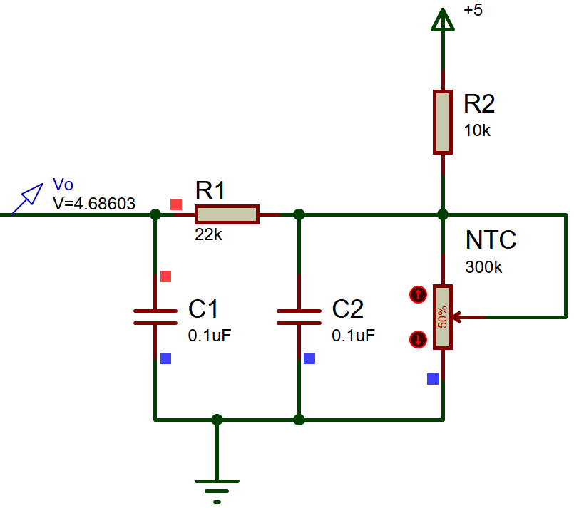

Figure 1: Proposed circuit for getting ADC value

A low pass RC filter is being used to reject all unwanted high frequencies of nearby electrical signal. Even, a voltage divider circuit is being used to get stable value of Vout.

From this circuit Vout will be

$Vout=\frac{NTC}{R2+NTC}×Vin$… … … … … … … … … … … *i*

Where,

* NTC = Resistance of NTC Thermistor
* R2 = Fixed Resistance
* Vin = Supply Voltage (+5V)
* Vout = Resultant voltage

Moreover, we can also get Vout from ADC value calculation. In a microcontroller of x-bit of ADC resolution, Vout will be

$Vout=\frac{ADC}{2^{x}-1}×Vin$

We can build a relation with these two equations,

$Vout=\frac{NTC}{R2+NTC}×Vin=\frac{ADC}{2^{x}-1}×Vin$… … … … … … *ii*

As $Vin ≠0$, we can re-write equation ii as

$ADC=\frac{NTC ×\left(2^{x}-1\right)}{R2+NTC}$… … … … … … … *… … … … iii*

Here only NTC is a variable argument. Therefore, ADC value will vary in accordance with the variation of NTC Resistance.

Secondly and final step is to calculate Temperature from ADC value using linear equation.

Every supplier of NTC thermistor provides a datasheet of NTC resistance with respect to temperature. ADC values need to be calculated with respect to NTC resistance from equation iii. Now, if we plot ADC and Temperature data, we will see it is not linear. But if it is segmented at 10˚C interval (colored individually), it seems to be linear as below

Figure 2: Determining slope and intercept values from Plotted Curve

The ADC values are in x-axis and Temperature values are in y-axis. Slope and intercepts values can be determined from this plot. We will check ADC value to find appropriate temperature region of selecting Slope and Intercept values.

Therefore, we can apply $T=c-(m×ADC)$ to determine Temperature directly from ADC value in a simple, stable and fasted way.

Implementation and Optimization:

I have developed a software through which we can see ADC value, NTC resistance as well as Calculated temperature. The simulation is attached as a picture below

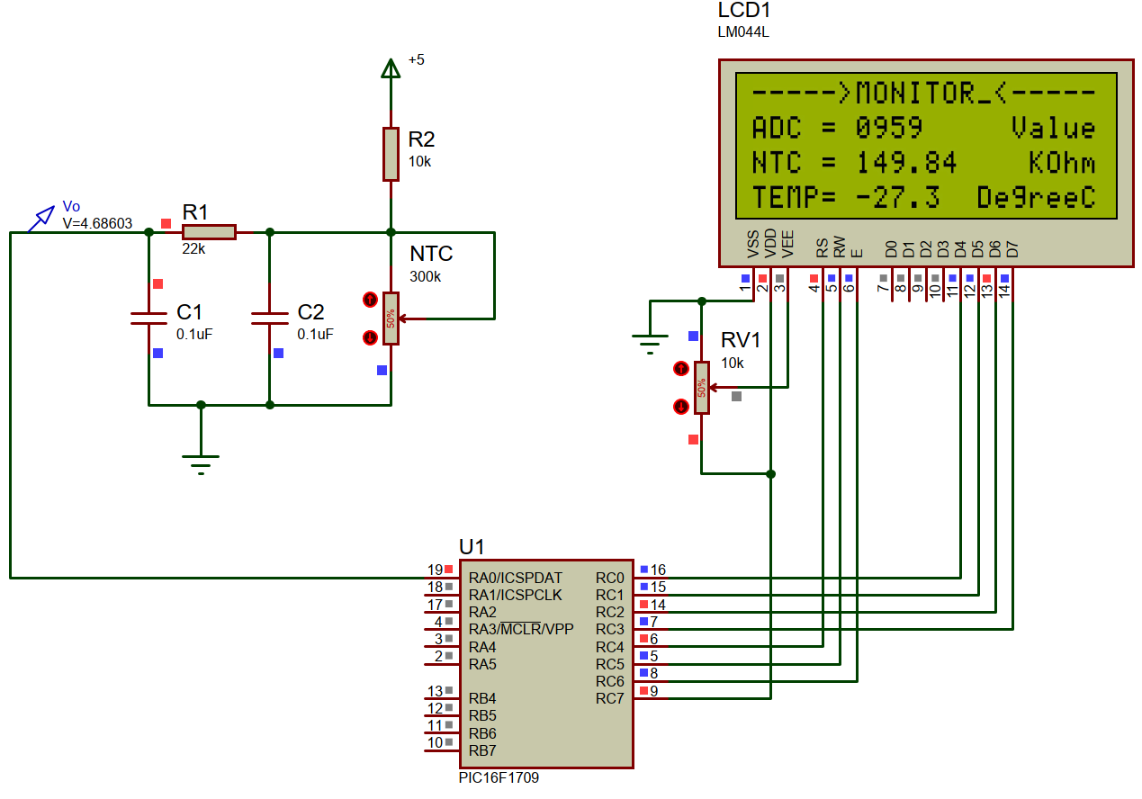

Figure 3: Simulation of computing Temperature from ADC

Even, the whole calculation is further optimized to get more stable dada and to avoid floating values.

My system is evaluating one ADC value from the average of 1024 samples. I am calculating the average by 10bits right shifting as ${ADC}_{Average}= \sum{ADC_{1024Samples}}≫10$ which is bit wise operation to perform a division by 1024.

In addition, slope and intercept values are multiplied by 10240 to avoid floating numbers and make calculation more accurate. Finally, 10bits right shifting will be done to get final temperature value (considering last digit as decimal value). As a summary final equation will be like

$T=\left(Cn-Mn ×ADC\right)≫10$

Where,

* T = Temperature multiplied by 10
* Mn = Slope value multiplied by 10240
* Cn = Intercept value multiplied by 10240
* ADC = Average ADC value

Let us demonstrate the simulation of Figure-3. Here goes the process step by step.

1. ADC: $959=\sum{ADC_{1024Samples}}≫10$

Average value of 1024 samples from Microcontroller ADC Read function

1. NTC: $149.84=\frac{ADC}{2^{x}-ADC}×1000$

Calculate NTC resistance from ADC.

1. As per ADC value and from Figure-2 plot slope and intercept values can be determined with a multiplication by 10240.

Mn : $0002503=0.2444 ×1024 ×10$

Cn : $2121523=207.18×1024 ×10$

1. T : $-273=\left(Cn-Mn ×ADC\right)≫10$

10bits right shifting to perform a division by 1024

1. Finally, we have computed the temperature as -27.3˚C from ADC value only.

Advantages and Applications:

Temperature is being calculated directly from ADC value. Linear equation is used to reduce execution time and memory usage. Bit shifting operation is applied to avoid mathematical operation of division. Multiplication are being used to avoid floating values as float requires higher memory usage.

This algorithm can be applied in every electronic device which use NTC thermistor. Remember, you need to calculate slope and intercept values from the Datasheet provided by the NTC thermistor supplier.